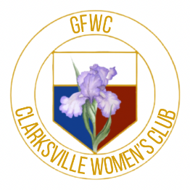
GFWC CLARKSVILLE WOMEN’S CLUB
Membership Application Form

Date ___________________

I, ____________________________________________, am interested in becoming a member of the GFWC Clarksville Women’s Club. I understand the objective of the Club is to promote the civic, charitable, literary, cultural, and educational interests of Clarksville and its surrounding communities operating as a non-profit association within the guidelines of Section 501C3 of the IRS Code. This club promotes the service tradition of the General Federation of Women’s Clubs (GFWC) to which it belongs.

_______________________________________________ ______________________ _____ _________
Street Address City State Zip

______________________________________ ________________________________________________
Preferred Telephone Email Address

______________________ _______________________________________________________________
Date of Birth (MM/DD) Signature Date

Dues: I agree to pay $40 annual dues to activate and maintain my membership status and voting privileges in the GFWC Clarksville Women’s Club

Payment: (Choose One) _________Online _________Check _________Cash

Interests Inventory: Please indicate one or more of the following Community Service Teams that you would be interested in working and focusing on.

_____ Arts & Culture _____ Conservation & Environment
_____ Education and Libraries _____ Health and Wellness
_____ Civic Engagement _____ Domestic Violence Awareness
_____ Child Advocacy

Skills and Talents: Please share any special knowledge, skills, aptitudes, talents, and background (including military service) that you have that may support the Club and its community service efforts.

Submission: Submit this form, accompanied by your annual dues payment if applicable to:
GFWC Clarksville Women’s Club, ATTN: Membership, PO Box 30471, Clarksville, TN 30740 OR email to gfwcclarksvilleWC@gmail.com OR you can apply online through our website at

www.gfwcclarksvillewomensclub.com

